
Concept of Operations
Guidance Document and Template
Northern Region Operations
June 2009

TABLE OF CONTENTS

1 INTRODUCTION 1
1.1 Objective 1
1.2 Audience 1
1.3 About the Icons 2
2 WHAT IS A CONCEPT OF OPERATIONS? 3
2.1 Why Develop a Concept of Operations? 4
2.2 Role within the Systems Engineering Process 7
3 ELEMENTS OF A CONCEPT OF OPERATIONS 8
3.1 Section 1 – Scope 9
3.2 Section 2 – Referenced Documents 11
3.3 Section 3 – Operational Description 12
3.4 Section 4 – Operational Needs 16
3.5 Section 5 – System Overview 18
3.6 Section 6 – Operational and Support Environment 23
3.7 Section 7 – Operational Scenarios 26
3.8 Section 8 – Next Steps 28
4 DEVELOPING A CONCEPT OF OPERATIONS 29
5 REFERENCES 32
APPENDIX – CONCEPT OF OPERATIONS TEMPLATE 33

INTRODUCTION
The Virginia Department of Transportation’s (VDOT) Northern Region developed this document to provide guidance to transportation professionals as they seek to develop and use Concepts of Operation to define Northern Region Operations (NRO) ITS projects. This document is closely based on Federal Highway Administration’s (FHWA) primer on ‘Developing and Using a Concept of Operations in Transportation Management Systems’.

Objective
The Concept of Operations Guidance Document is designed to provide the reader with insight into VDOT NRO’s recommended requirements for an operations-focused Concept of Operations document. As such, it offers:
- Guidance on developing the Concept of Operations, including what information to include, how to begin the development process, stakeholder identification and involvement in the process, and identifying resources that will facilitate the development process.
- Guidance on using Concepts of Operations, including highlights of the entire systems engineering process.
- Specific examples of good practice, including examples from past VDOT NRO Concept of Operations.

Audience
This document is written for transportation professionals involved in the VDOT NRO project planning and development of ITS projects within the VDOT NRO footprint. However, the document is relevant to a wide audience and is intended to communicate essential information about Concepts of Operation to a variety of transportation professionals.

The following audiences will find the guidance document useful for the following reasons:
- State and Local DOT Management – Transportation managerial professionals will find that this document reiterates the necessity of system stakeholder communication. A Concept of Operations is a critical foundation for such communication.
- State and Local DOT Technical Staff – Technical staff working on operations projects that deal with all aspects of the system’s operation, including but not limited to design engineers, integration and test engineers, operators of the various system functions, and maintenance staff, will find that this document demonstrates how a Concept of Operations helps to clarify agency goals and objectives and keep all involved personnel on the same page.
- Transportation Consultants – Transportation consultants that are working within or in conjunction with VDOT NRO, performing work that includes repairs and maintenance, system support services, etc., will find that this document shows how a Concept of Operations assures that the ‘client’ has communicated, at the highest possible level, what they want the system to be – adding clarity and helping to avoid scope creep for all parties.

This document is also written for non-technical community leaders, local officials, and others who have an interest in transportation issues and who may influence resource allocation decisions. Such individuals may have as much input, if not more, in some cases, into transportation system development decisions as transportation professionals themselves.

Information presented in this document is presented with the understanding that not all of the individuals or groups reviewing this document will be at the same point operationally or developmentally. As such, consideration will be given to those organizations, agencies and individuals who:
- Are new to a Concept of Operations.
- Have limited experience with developing a Concept of Operations for VDOT NRO.
- Are seeking to develop and use a Concept of Operations for an existing system.

About the Icons
Icons are used to highlight pertinent information throughout this document.

 | This "Reference / Tools” icon identifies resources that offer additional information related to systems engineering, including books, reports, presentations, and other documents. It also identifies references and/or tools may that support some aspect of the development of the Concept of Operations.
 | This "Hint" icon identifies suggestions that may improve the systems engineering analysis or the quality of the systems engineering products that are created. Usually based on actual experience, these are ideas that have worked in the past.
 | This “Outreach” icon identifies steps in the Concept of Operations development where VDOT NRO staff or regional stakeholders need to be included in the process. Meetings, conference calls, and other means should be used to solicit input from stakeholders.
 | This “Example” icon identifies real-world examples from existing VDOT NRO Concept of Operations. These examples are intended to assist the reader with understanding the expected content that should be included in a Concept of Operations prepared for VDOT NRO.
 | This "Caution" icon flags warnings. In contrast to tips, these are problems that have been encountered that you should avoid. Also frequently based on actual experience, these are ideas that have NOT worked in the past.

WHAT IS A CONCEPT OF OPERATIONS?
The Concept of Operations is a user-oriented document that describes characteristics of a to-be-delivered system from the user’s viewpoint. The Concept of Operations is used to identify and communicate overall quantitative and qualitative characteristics of systems to the user, developer, maintainer, and other affected parties.

The Concept of Operations should be a document available, and relevant, to all stakeholders in the system, no matter what their background or role within the system. It should be as readable and relevant to high-level decision makers as it is to the project manager and the system operator. The Concept of Operations answers the who, what, when, where, why, and how for the new or existing system:
- What – What are the known elements and the high-level capabilities of the system?
- Where – What are the geographical and physical extents of the system?
- When – What is the time sequence of activities that will be performed?
- How – What resources do we need to design, build, or retrofit the system?
- Who – Who are the stakeholders involved with the system?
- Why – What does your organization lack that the system will provide?

Figure 1 provides a conceptual representation of a Concept of Operations. This includes information about the system itself as well as the operational environment (i.e., facility, personnel, hours of operation) and the support environment (i.e., how will the system be maintained).

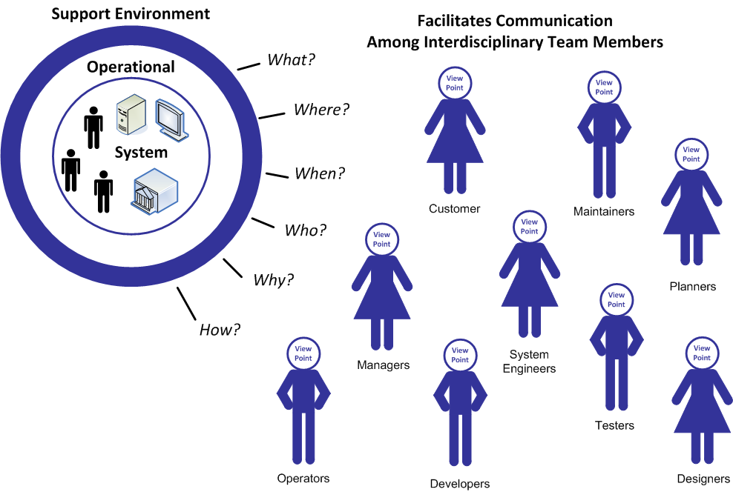

Figure 1. Concept of Operations Conceptual Representation (Graphic adapted from ANSI/AIAA’s “Guide for the Preparation of Operational Concept Documents” ANSI/AIAA G-043-1992).

This information is gathered through facilitated communication among interdisciplinary team members including various regional stakeholders. This includes planners, system engineers, developers, operators, maintainers, customers, and other stakeholders that interact with the system. Development of a Concept of Operations should be led by a facilitator that can engage communication between these stakeholders, has an understanding of regional stakeholder roles and responsibilities, and has knowledge of existing and future systems. The Concept of Operations documents agreement on:
- Goals, objectives, and expectations.
- Project Scope.
- Stakeholder responsibilities.
- How the system will operate.
- Operational and support environment.

 | The Concept of Operations is not a “wish list” generated by users that engineers focus on briefly prior to beginning the hard work of figuring out what the system is actually going to do. This perspective has several faults: a good Concept of Operations for a complex problem should be jointly developed by stakeholders and describe something that is “doable” in the engineering sense. The result of applying the faulty “wish list” perspective is often a development effort that rapidly devolves into cycles of reduced expectations and cost overruns.

Why Develop a Concept of Operations?
There are a variety of benefits that can accrue to an organization or group of organizations from developing a Concept of Operations. When planning, designing, deploying, operating, and maintaining a project, defining a shared set of expectations is of critical importance. The Concept of Operations supports the development and documentation of these expectations to serve as the essential foundation for the project. The Concept of Operations provides structured, comprehensive guidance by:
- Identifying, and serving as a tool to engage the diverse array of stakeholders who will be impacted by the project.
- Identifying the users of the proposed system so that a description of user needs can be developed.
- Developing goals and objectives based on identified user needs and agreed upon vision for the project.
- Revealing institutional barriers to collaboration and suggesting ways to surmount the obstacles.
- Describing the current infrastructure and institutional framework.
- Providing a comprehensive view of how the proposed system will function under expected conditions (scenarios).
- Describing current operations within the region and describing how this will be affected by the proposed project.
- Differentiating between those functions and services that would provide greater benefit if approached at the regional level and those that should continue to be performed at the local level.
- Identifying the resources necessary to build, operate, and maintain the new system or service created by the project.
- Detailing the number and types of agreements needed to implement the proposed project.
- Defining the roles and responsibilities of the various agencies that will build, operate, and maintain the proposed system.

An additional benefit from stakeholder consensus is a decreased risk of project failure. The experiences of transportation professionals have shown that developing a Concept of Operations significantly increases the chance for success on the project. The stakeholder consensus integral to the Concept of Operations development process not only builds a unified vision and understanding of a new system, but also contributes to reductions in cost overruns, a more accurate definition of the system earlier in the development stage, and a decrease in the likelihood that stakeholder dissatisfaction will terminate the project. One transportation professional said of the Concept of Operations for a Transportation Management System that it is “not a silver bullet [i.e., not a cure-all to the problems of developing and maintaining a TMS], but it does decrease the likelihood of failure for a project.” The benefit of a Concept of Operations can best be described using an example:

EXAMPLE #1 – WHY DEVELOP A CONCEPT OF OPERATIONS?


A local transportation agency (i.e., a County Department of Transportation) is planning to take a more proactive approach toward operating its roadways and decided to move forward with a closed circuit television (CCTV) project on the ‘County Parkway’. The project originated from the need for the agency to monitor traffic on its roadways and so the agency could update its traffic signal timing plans during major incidents/events. The project seemed straightforward, simply deploy CCTV cameras in the field and tie them into the County’s new Advanced Traffic Management System (ATMS).

As the County began moving forward with its CCTV project, they were approached by the County Police Department asking if they could get access to the video images once the project was complete. The Police Department wanted to be able to monitor the roadway during incidents and emergencies. Understanding the Police Department’s need the County decided to include a fiber connection between its Transportation Operations Center (TOC) and the Police Dispatch Building.

A few weeks later, the County learned that VDOT was also thinking about putting CCTV cameras on the ‘County Parkway’ and asked the County if they could have a direct feed to the cameras instead of installing their own cameras on the same road to assist with incident management. The media also expressed a need for the cameras to allow them to show traffic conditions on the news. The County soon recognized that the cameras could serve multiple regional needs, but they did not have funding to install and maintain fiber between each agency’s facilities. It also seemed like an opportunity for the region to leverage various funding sources for a larger more comprehensive project.

Rather than moving forward with what seemed like a “stove-piped” project, the County decided to develop a Concept of Operations to identify all stakeholder needs and to leverage various funding sources between the County and VDOT. A series of stakeholder outreach meetings were scheduled to solicit input for the new project. During these meetings the County learned that in addition to the County Police, VDOT, the media, and Virginia Department of Emergency Management, and Metropolitan Area Transportation Operations Coordination facilitator and a few additional regional stakeholders also wanted to be able to view the cameras. The County also learned that VDOT had an existing ‘Video Sharing Clearinghouse’ that allowed video images to be shared with agencies over the web where County can leverage VDOT’s contract to join the network.

A Concept of Operations was developed and it was stakeholder consensus determined that rather than having fiber connections between each agency it would be best to leverage VDOT’s ‘Video Sharing Clearinghouse’. This would result in a significant cost savings to the County and promoting regional coordination.

Role within the Systems Engineering Process
The International Council of Systems Engineering (INCOSE) defines systems engineering as following:

“Systems Engineering is an interdisciplinary approach and means to enable the realization of successful systems. It focuses on defining customer needs and required functionality early in the development cycle, documenting requirements, and then proceeding with design synthesis and system validation while considering the complete problem.

Systems Engineering integrates all the disciplines and specialty groups into a team effort forming a structured development process that proceeds from concept to production to operation. Systems Engineering considers both the business and the technical needs of all customers with the goal of providing a quality product that meets the user needs.”

Since it was first developed in the 1980s, the "V" model has been refined and applied in many different industries. Wings have been recently added to the "V" as part of its adaptation for ITS to show how project development fits within the broader ITS project life cycle. The left wing shows the regional ITS architecture, feasibility studies, and concept exploration that support initial identification and scoping of an ITS project based on regional needs. A gap follows the regional architecture(s) step because the regional architecture is a broader product of the planning process that covers all ITS projects in the region. The following steps in the "V" are for a specific ITS project. The central core of the "V" shows the project definition, implementation, and verification processes. The right wing shows the operations and maintenance, changes and upgrades, and ultimate retirement or replacement of the system. The wings are a key addition to the model since it is important to consider the entire life cycle during project development.

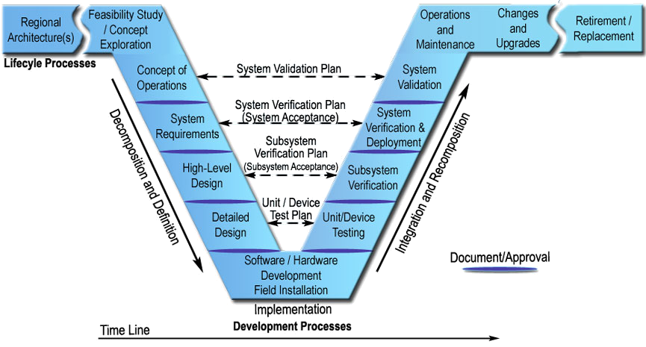

Figure 2. The Systems Engineering “Vee Diagram”.

As shown in the "V", the systems engineering approach defines project requirements before technology choices are made and the system is implemented. On the left side of the "V", the system definition progresses from a general user view of the system to a detailed specification of the system design. The system is decomposed into subsystems, and the subsystems are decomposed into components – a large system may be broken into smaller and smaller pieces through many layers of decomposition. As the system is decomposed, the requirements are also decomposed into more specific requirements that are allocated to the system components.

VDOT’s Northern Virginia ITS Architecture was expanded in 2009 to become a truly regional architecture (no longer VDOT-centric) to cover the entire NRO boundary. It is available at www.vdot-itsarch.com. VDOT NRO’s project proposal template and Feasibility Review Process prior to funding consideration are normally complete prior a project establishment and Concept of Operations development. They can be accessed from the architecture website.

As development progresses, a series of documented baselines are established that support the steps that follow. For example, a consensus Concept of Operations supports system requirements development. A baseline set of system requirements then supports system design. The hardware and software are implemented at the bottom of the "V", and the components of the system are then integrated and verified in iterative fashion on the right. Ultimately, the completed system is validated to measure how well it meets the user's needs.

ELEMENTS OF A CONCEPT OF OPERATIONS
This section identifies the core elements of VDOT NRO’s Concept of Operations template. The template leverages input from two recommended ITS Standards for developing a Concept of Operations. These standards include the ANSI / AIAA standard (G-043-1992) and the IEEE standard (P1362 V3.2). These Concept of Operations standards contain similar information, but are packaged in a different manner.

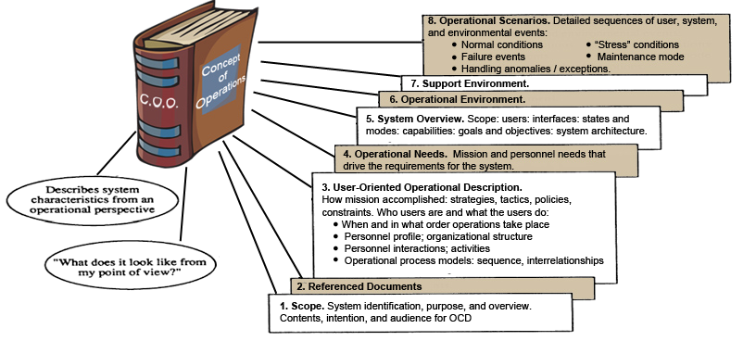

Figure 3. The Core Elements of a Concept of Operations (Graphic adapted from ANSI/AIAA’s “Guide for the Preparation of Operational Concept Documents” ANSI/AIAA G-043-1992).

Figure 3 depicts the eight recommended components of VDOT NRO’s Concept of Operations: (1) Scope, (2) Reference Documents, (3) Existing Conditions, (4) Operational Needs, (5) System Overview, (6) Operational Environment, (7) Support Environment, and (8) Operational Scenarios. A description of each section is discussed in more detail below. Additionally, examples from previous VDOT NRO Concepts of Operation are provided as references.

Section 1 – Scope
Scope is the first section of the Concept of Operations and presents an overview of the document. It includes the following components:
- Introduction, System Overview, and Purpose. The Concept of Operations should start with an introduction of the proposed system, including a brief overview of the system and its intended purpose. This overview should be done at a high-level and should be independent of specific technologies or vendors. The introduction should also define the contents of the document, the intention of the Concept of Operations, and its intended audience.
- Project Limits. Where applicable, this section should define the project limits – including both a written description and a map of the geographic boundaries. An example of a project limit description is provided in Example 2. The description and map should clearly define the geographic boundaries, setting the stage for the remainder of the document.
- System Vision, Goals, and Objectives. This section defines the vision, goals, and objectives of the proposed system. Goals and objectives are statements that describe what the system will accomplish, or the business value the system will achieve. The goals and objectives will serve as guiding principles providing the framework, helping stakeholders define system needs and components.

Reference VDOT NRO’s 2008 Strategic Plan when defining the system’s goals and objectives. The strategic plan identifies VDOT NRO’s plan make roadway travel safe, efficient, and reliable. All VDOT NRO projects should map back to this Strategic Plan which can be downloaded from www.vdot-itsarch.com.
- Role of the Concept of Operations within the Systems Engineering Process. Section 1 – Scope should also briefly define the Role of the Concept of Operations within the Systems Engineering Process. This section should provide an introduction to the Systems Engineering Process for the audience that is unfamiliar with the process. The Systems Engineering “V Diagram” should be discussed and the role of the Concept of Operations should be included in the discussion.

This VDOT NRO Guidance Document is an excellent reference for defining the role of the Concept of Operations in the Systems Engineering Process. Leverage text from Chapters 2 and 6 of this guidance document.

EXAMPLE #2 – PROJECT LIMITS
(from VDOT NRO’s I-66 Spot Improvement Concept of Operations)

The Virginia Department of Transportation (VDOT) is proposing a series of spot improvements along westbound I-66 in Arlington and Fairfax Counties to help improve mobility and safety of the corridor. These spot improvements will also help facilitate evacuations from Washington, D.C. in the case of an emergency. The I-66 Spot Improvements consists of three construction segments which will extend the auxiliary lane in the following segments, described below:

- Segment 1 – between Fairfax Drive and Sycamore Street;
- Segment 2 – between Washington Boulevard and the Dulles Connector; and
- Segment 3 – between Lee Highway / Spout Run Parkway and Glebe Road.

The I-66 Spot Improvements are scheduled to begin in Fall 2008 and would be completed by approximately 2010, depending on the procurement approach and staging. Design-build procurement is being considered by VDOT, and construction schedule depends on funding availability. It is possible all 3 segments or just individual segments may be constructed during a specific time frame.

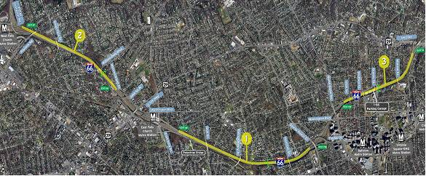

This project area is one of the original routes operated and managed by the VDOT’s ITS / Operations Program. Existing ITS components along this corridor include traffic detection, closed circuit television (CCTV) cameras, dynamic message signs (DMS), ramp metering, and Safety Service Patrols. These components are currently being operated by VDOT’s Northern Region Traffic Management Center (TMC) located in Arlington, Virginia (moved in late 2008 to Fairfax). Although there have been some recent upgrades – notably modernized dome-type CCTV cameras, non-intrusive detection in lieu of the older loop detection, and replacement of the original coaxial communications with fiber optics – many devices found in the project area are in dire need of upgrades.

Section 2 – Referenced Documents
In this section, developers of the Concept of Operations list the resources used when developing the document. This clarifies the sources of information that went into the document and provides the reader with guidance to find additional information. Types of reference documents that are typically listed include:
- Business Planning Documents.
- Concepts of Operation for related systems.
- Requirements for related systems.
- Studies that Identify Operational Needs.
- Stakeholder Outreach Meeting Minutes.

VDOT NRO has several existing documents that can be utilized when developing a Concept of Operations. These documents include:
- VDOT NRO’s Strategic Go-Forward Plan (2005).
- VDOT NRO Strategic Plan (2008).
- VDOT NRO ITS Architecture (http://www.vdot-itsarch.com/Default.htm).
- VDOT NRO ATMS (OpenTMS) Concept of Operations (2007).
- VDOT NRO Standard Operating Procedures (SOP) (2007).
- VDOT NRO ITS Master Plans (currently DMS, CCTV, and Detection, 2008).
- Other Concepts of Operation developed for VDOT NRO.
A well-defined regional ITS architecture provides a good starting point for developing a Concept of Operations for an ITS project. The components of the regional ITS architecture provide a high-level description of the ITS systems in the region, which can often be directly incorporated into a project Concept of Operations. Several of the regional ITS architecture components can be used. The following figure maps the architecture to various sections of the Concept of Operations. One may leverage VDOT Northern Virginia ITS Architecture in the following identified areas for the development of Concept of Operations.

Section 3 – Operational Description
Section 3 – Operational Description is used to describe the system from the user’s vantage point. Its purpose is to outline the strategies, tactics, policies, and constraints within which the system will operate and how the goals and objectives in Section 1 – Scope will be met by the system implementation. Information that should be highlighted in this section includes:
- Stakeholder Roles and Responsibilities.
- Locations of Existing ITS Infrastructure.
- Operational procedures and sequences of events.

The section should begin with a description of regional stakeholder roles and responsibilities. This early documentation of "who does what" grabs the stakeholders' attention and supports development of the new system. Typically, roles and responsibilities are documented as a list or in tabular form. This early documentation of "who does what" supports development of system requirements and operational agreements and procedures in future steps.

This section also needs to identify the location of existing ITS infrastructure within the project limits and brief description of the state of the existing infrastructure (e.g. approaching end of life cycle). The infrastructure may include ITS devices (i.e., DMS, CTV cameras, etc.), coverage areas of safety service patrols or police officers for incident management, location of fiber, or any other infrastructure that may be pertinent to the coverage area.

Finally, the operational procedures that the organization follows, including sequences of events, to address common conditions or events should be documented from the perspective of how the system will operate or how the procedures need to change given the capabilities of the system installed. The functionally, as it pertains to the new system, should be discussed.

 | VDOT NRO’s ITS Architecture (http://www.vdot-itsarch.com/Default.htm) includes a list of regional stakeholders and description. Additionally, interconnects and information flows identified in the architecture can be used to develop draft stakeholder roles and responsibilities. The Architecture can also be used to identify existing systems that the new system may interact with. VDOT NRO also has GIS layers with existing ITS Device locations. These GIS layers can be used to develop maps of existing DMS, CCTV cameras, detection, lane control signals, truck rollover warning systems, fiber communications, and other ITS devices. Contact VDOT NRO Planning and Programming for access to the GIS files.
 | The Concept of Operations developer should hold a stakeholder outreach meeting with appropriate stakeholders to gather input and verify stakeholder roles and responsibilities, and identify existing systems, device locations, and processes. This outreach meeting should be included in the Scope of Work.
EXAMPLE #3 – EXISTING CONDITIONS
(from VDOT NRO’S Dulles Rail TMP Concept of Operations)


Stakeholder Roles and Responsibilities

VDOT’s Northern Regional Operations (NRO) is the primary stakeholder that owns, operates, and maintains the freeway and arterial ITS/Operations components within the project area. Although VDOT is the primary stakeholder, operations in the project area require the skills and expertise of a diverse group of stakeholders. This group includes (1) Dulles Corridor Metrorail Project, (2) other VDOT mega projects, (3) law enforcement, (4) fire and rescue, (5) emergency medical services, (6) transportation agencies, (7) towing and recovery service providers, (8) media, and (9) information service providers. The roles and responsibilities of these stakeholders are defined below.

Law Enforcement. Law enforcement agencies from the state and county levels are responsible for incident management in the project area. This includes the Virginia State Police, MWAA Police, and Fairfax County Police. In general, participation from these agencies is dictated by the jurisdiction in which the incident occurs. State Police agencies are responsible for incident management on the interstate highways (I-495 and I-66), MWAA Police are responsible for incidents on the DTR and DIAAH, and Fairfax Country police are responsible for arterials such as Routes 7 and 123. Overall, incident management roles and responsibilities assumed by law enforcement agencies include:

- Assist in incident detection
- Secure the incident scene
- Assist disabled motorists
- Provide emergency medical aid until help arrives
- Coordinate with the TMC for incident response and management
- Direct traffic at the incident scene
- Conduct accident investigations
- Supervise scene clearance

Fire and Rescue. Fire and rescue services are provided by local fire departments. Fairfax County Fire and Rescue is responsible for the Tysons Corner Project area. Roles and responsibilities assumed by the fire departments include:

- Provide traffic control until police or DOT arrival
- Provide emergency medical care
- Provide initial HAZMAT response and containment
- Fire suppression
- Rescue crash victims from wrecked vehicles
- Rescue crash victims from contaminated environments
- Assist in incident clearance

Description of Existing Systems

The existing ITS information network is depicted in the figure below. This diagram illustrates the various ITS components involved and the different entities with which they communicate throughout the ITS network.

At the center of ITS operations in this region is the VDOT NRO Traffic Management Center (TMC) in Arlington, Virginia (moved to Fairfax in late 2008). This facility serves as the hub through which nearly all ITS information passes and therefore provides management and coordination of the various ITS components throughout the region.

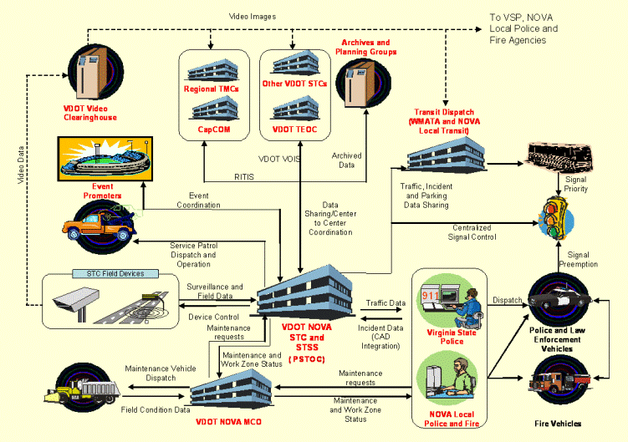

Existing ITS Infrastructure

The closed circuit television subsystem is a collection of cameras owned, operated and maintained by VDOT. These cameras provide live video feeds of traffic conditions to personnel at the TMC. Currently in the project area, VDOT has eight operational cameras. Full construction area coverage is not provided by these cameras; for example there is currently no CCTV coverage of the DTR and I-495. The identification number and location of each camera can be found in the following list and figure. Note that one of these cameras is mounted to a building rooftop; the others are pole mounted.

- CCTV @ Route 7 – Leesburg Pike & SAIC Drive (SAIC rooftop)
- CCTV @ Route 7 – Leesburg Pike & Route 267 – Dulles Toll Road
- CCTV @ Spring Hill Road & Jones Branch Road
- CCTV @ Route 123 – Chain Bridge Road & International Drive
- CCTV @ Route 7 – Leesburg Pike & Route 123 – Chain Bridge Road
- CCTV @ Route 123 – Chain Bridge Road & Boone Boulevard
- CCTV @ Route 7 – Leesburg Pike & Fashion Boulevard
- CCTV @ Route 7 – Leesburg Pike & International Drive

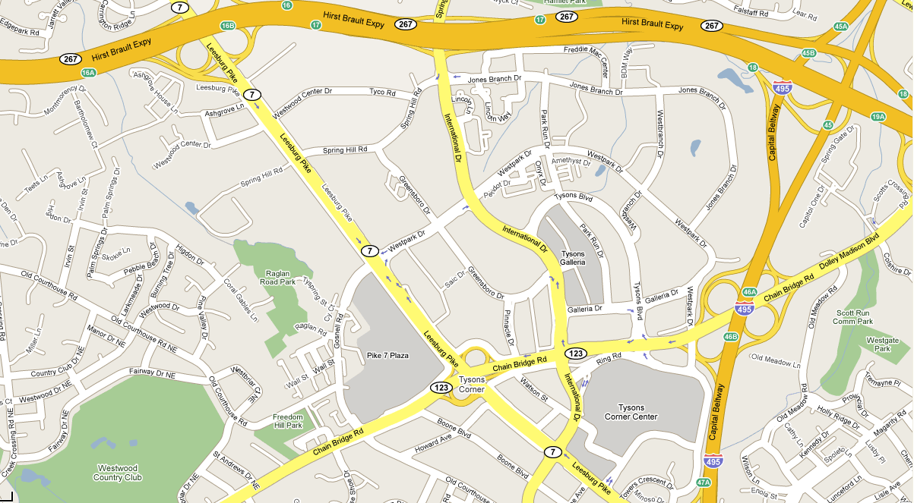

Section 4 – Operational Needs
This section should identify needs expressing the underlying objectives of stakeholders in terms of what they are trying to accomplish as it relates to the new system but are not currently satisfied with the existing systems or environment. Operational Needs are not requirements. The needs identified in the Concept of Operations should be deliberately high-level and focus on outcomes rather than methods.

Following the structure of the template, this section builds on the previous section of the Concept of Operations outline. Section 1 – Scope identifies the vision, goals, and objectives for the proposed system. And Section 3 – Operational Description identifies the stakeholder roles and responsibilities, locations of existing ITS infrastructure, and existing operational procedures and sequences of events under which the new system will operate and how the system will aid in meeting the goals and objectives of the stakeholders. The needs should represent the capabilities, resources, and functionality not currently met by existing systems in pursuit of the stakeholder goals and objectives.

There is a temptation at this point to make assumptions about system design. The Concept of Operations should address what is to be done, but not how it will be implemented. That will be determined later during design.
Operational needs should be developed independent of technological solutions. Their intent is to define “what” is needed, not “how” it will be done. This allows several technological solutions to be evaluated. For example, operational needs should state that “volume, speed, and occupancy data is needed on a 5 minute basis.” This allows several different technologies (i.e., radar detection) to be evaluated instead of stating that “RTMS detectors” are needed.

This section should be organized in a structured manner to be leveraged in the future when high-level requirements and a validation plan is developed. It is recommended that the Operational Needs are included in a matrix that will allow designers to trace high-level requirements back to the needs via a traceability matrix.

Operational Needs should be identified through a series of stakeholder outreach meetings. The meetings should group similar stakeholders together to allow for focused discussion. Outreach meetings should be included in the Scope of Work. The exact number of meetings will vary based on the complexity of the Concept of Operations and the size of the project.

EXAMPLE #4 – OPERATIONAL NEEDS
(from VDOT NRO’S CCTV Master Concept of Operations)
Freeway Operations staff use the CCTV system to detect and verify freeway incidents such as accidents, breakdowns, and debris on the roadway as well as to monitor planned and unplanned events such as lane closures for road work. Freeway Operations staff need to be able to verify the performance of other ITS systems using the CCTV system. The Freeway Operations staff need the system to help increase operator efficiency through a Video Incident Detection (VID) expert system to notify operators of road condition changes in a camera’s feed while another feed is being viewed.

System objectives based on Freeway Operations user needs are presented in the following traceability matrices.

Objective | User Need
4.1.1.1 Corridor Management | - Monitor freeways and arterials with limited gaps  - Ability to monitor and compare parallel arterials that can support diversion during an incident and report on congestion  - Monitor regular lanes as well as express and reversible lanes
4.1.1.2 Condition Monitoring | - Provide camera coverage of full mainline laneage in both directions  - Ability to monitor interchanges: merge areas, diverge areas, and weave areas  - Avoid visual obstructions such as vegetation, ramps, overpasses, buildings, and signs  - Ability to view images in low light conditions  - Ability to view images in fog, rain, snow conditions  - Ability to view steady, clear image  - Cameras programmed to return to preset angle, zoom, and focus when not under active operator control.
4.1.1.3 Inform Public and Media | - Create low bandwidth copy of TMC video feed and make available to general public via internet sites such as VDOT 511 webpage  - Create low bandwidth copy of TMC video and provide to media and ISPs through a media feed  - Disable public feeds during emergencies, security events, or other events of a sensitive nature (i.e., fatalities)
4.1.1.4 Regional Coordination | - Share video images with regional stakeholders (state and local DOTs, Police, Fire & Rescue)  - Share video images via Video Clearinghouse  - Share video images via RITIS

Section 5 – System Overview
Section 5 – System Overview includes a brief overview of the proposed system, relationships and interfaces with other systems / stakeholders, proposed high-level locations of infrastructure, and discussion of software and communication requirements, and key considerations for its design. Included in this section is a Project Architecture. Note that the Project Architecture is not a design document [that will be done later]. Instead it provides a structure for describing the operations, in terms of where the operations will be carried out, and what the lines of communication will be.

This section is the “meat” of the Concept of Operations, describing the proposed system based on Operational Needs. The components of this section will depend on the complexity of the proposed system. However, it is anticipated that the following items should be addressed in the Concept of Operations:

- System (or Subsystem) Overview.
  - Description of the System / Subsystem.
  - Proposed Content / Functionality (if necessary).
  - Proposed Device Locations (if necessary) – including descriptions and maps.
  - Software Implications (if necessary).
  - Communication Requirements (if necessary) – including descriptions and maps.
- Project Architecture.
  - Interconnect Diagram.
  - Information Flow Diagrams.
  - Stakeholder / Element Descriptions.

In many cases, the proposed system may be comprised of several subsystems. For example, a Concept of Operations for a roadway construction project may consist of DMS, CCTV camera, and detection subsystems. In this case, each subsystem should be discussed independently in regards to its proposed content / functionality, proposed device locations, software implications, and communications requirements.

A major component of Section 5 – System Overview is the project architecture. The project architecture provides a framework that identifies the institutional agreement and technical integration necessary to interface a major ITS project with other ITS projects and systems. The project architecture addresses application of the proposed system with a focus on integration and operation of the system(s). The project architecture should be limited to the proposed architecture and integrated into the regional ITS architecture at a later date. Components of the project architecture include a description of the stakeholders and elements, interconnect diagrams, and information flow diagrams.

The Turbo file for VDOT NRO ITS Architecture can be downloaded from the ITS Architecture website (http://www.vdot-itsarch.com/Default.htm). Project Architectures should be created in Turbo Architecture and should be based on the stakeholders and elements in the existing regional architecture. If the proposed project architecture is not fully agreeable with the regional architecture, one should notify VDOT NRO via the architecture website feedback page.

EXAMPLE #5 – SYSTEM OVERVIEW
(primarily from VDOT NRO’s DMS Travel Time Pilot Project Concept of Operations)

This DMS Travel Time Project is intended to be a “demonstration project” or “pilot project” for VDOT’s Statewide Travel Time Program. VDOT NRO will work closely with VDOT Central Office to deploy a travel time system that is consistent with the Department’s statewide vision, standards and guidelines. Additionally, the Pilot Project is expected to support the development efforts currently being conducted by the Department to implement a Statewide Travel Time Program.

Planning and design of the Pilot Project will adhere to all Systems Engineering principals and processes as required by FHWA 23 CFR 940. The System’s Engineering process will provide an optimal framework for ensuring successful implementation of the project. The NRO Pilot Project will last for a period of two (2) years or until the end of the I-95 Corridor Coalition’s Probe Data project contract, whichever comes first.

Travel Time Data

A primary goal of the Pilot Project is to leverage and integrate existing resources in order to facilitate a rapid deployment of the pilot project. While the INRIX data remains available for free of charge for another two years under the I-95 Corridor Coalition Probe Data Project, it was determined that NRO should take advantage of this resource while available.

It is expected that this Pilot Project will simply utilize INRIX data for travel time information. As VDOT NRO’s DMS Travel Time Program matures, the travel time module is expected to aggregate data from various future data sources including private sector data feeds, detector data, and toll tag data. When these data sources are available, the travel time module is expected to aggregate data from various sources and to fuse the data.

INRIX travel time data will be transmitted through an XML stream between the I-95 Corridor Coalition’s Probe Data Project’s data clearinghouse and VDOT. The data will include:

- Speed,
- Travel Time,
- Confidence level ratings (10, 20, 30)
- Expected Speed,
- Free Flow Speed,
- Road Segments (TMC location codes)
- Update Rate / Latency (Agencies access every 2 minutes)

OpenTMS Software Module

A new travel time software application will be required in order to aggregate INRIX travel time data, automatically calculate and disseminate travel times, and provide a command and control platform for the operations and management of the travel time system. In order to meet this requirement, it was determined to develop a new travel time module as an integrated feature with the new OpenTMS software application recently deployed by NRO. The travel time algorithm being developed for this Pilot Project will provide for a fully automated system, including:

- Travel time calculations,
- Message selection,
- Message derivation,
- Message dissemination,
- Data quality assessment,
- Verification and validation features, and
- Information quality assessment.

The travel time module will also provide a command and control graphical user interface (GUI) for operator system management including the ability to configure or override travel time messages and the travel time system by those authorized to do so.

Dynamic Message Signs

One of the first planning tasks in framing the new DMS travel time system was identification of potential DMS ideal for posting travel time messages. Identification of candidate sign locations and evaluation and selection of potential sites were based on preliminary citing criteria including:

- DMS availability
- DMS size and configuration
- Provision of travel times for general purpose lanes (only)
- Potential for diversion routing
- Potential for messaging references to well known landmarks, and
- Reliable, existing infrastructure

The project test sites (DMS locations) were selected through a multiple-stage evaluation process. A report was generated from OpenTMS detailing all existing regional DMS that meet the minimum operating and configuration criteria for the project. The report and GIS mapping were used to conduct a preliminary in-house evaluation of candidate signs. Following the preliminary in-house evaluation, a comprehensive field review was conducted to confirm test site locations.

Candidate DMS Travel Time maps (Figure x) are also included in this report. These maps depict the location of the DMS as well as potential travel time messages.

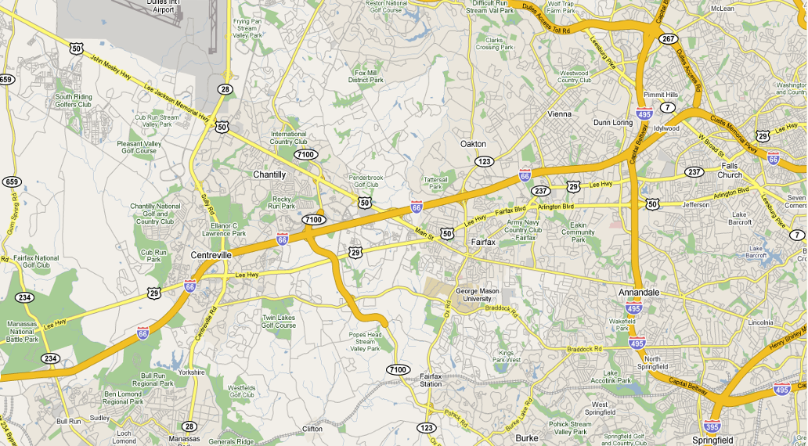
TRAVEL TIME TO:
RT 50 10-12 MIN
I-495 20-24 MIN
TRAVEL TIME TO:
I-495 8-10 MIN
DC 24-30 MIN

Project Architecture

The following information flow diagram illustrates the elements of the Northern Virginia ITS Architecture that will be implemented with the project. Further details regarding the individual elements of the diagram can be found at the ITS Architecture website.

System Architecture

Travel times will be generated by a new travel time software module, to be integrated with VDOT NRO’s existing ATMS – OpenTMS. The module will autonomously aggregate travel time data and information (generated by INRIX, Inc. for the I-95 Corridor Coalition project), calculate travel times and automatically generate messages and disseminate travel time messages as default message on selected DMS signs in NRO without operator’s action. The following graphic provides a high-level overview of the Pilot System Architecture.

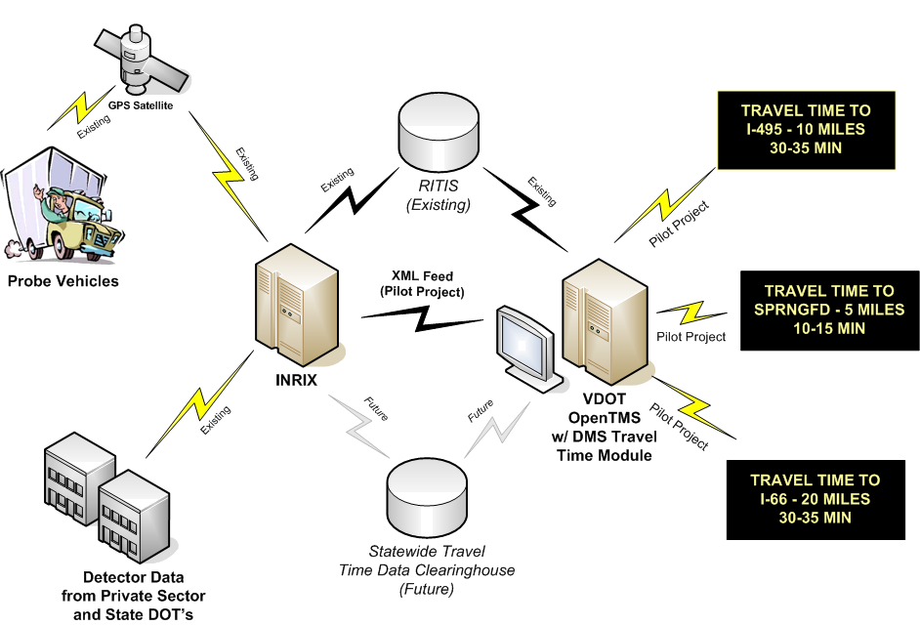

Section 6 – Operational and Support Environment
Although the ANSI/AIAA standard describes two sections, there is considerable overlap between them. Therefore, it is recommended that the sections be combined to provide information about the general operational environment for operation of the new system (or created by the change in the current system). This section includes the following environmental characteristics:
- Facilities.
- Equipment.
- Hardware.
- Software.
- Personnel.
- Operational Procedures.
- Support Necessary to Operate the Deployed System.

This section describes the physical operational environment in terms of facilities, equipment, computing hardware, software, personnel, operational procedures and support necessary to operate the deployed system. For example, it will describe the personnel in terms of their expected experience, skills and training, typical work hours, and other activities that must be or may be performed concurrently.

It is important to include operations and maintenance staff in Concept of Operations discussions. Often times, personnel and maintenance needs are overlooked. This would result in systems being built that cannot be operated or maintained by current staffing levels or tools.

EXAMPLE #6 – OPERATIONAL AND SUPPORT ENVIRONMENT
(from VDOT NRO’s Detection Master Concept of Operations)

This document identifies the need for several new applications for detectors, many of which require additional man‐hours of effort, new hardware and/or software, and new operating procedures. This section addresses each of these operational support areas.

Personnel

For the real‐time applications, TMC Operators may have additional responsibilities. For instance, applying traffic‐responsive ramp metering will require additional monitoring to ensure the system is functioning properly. However, at the same time, an improved congestion map and more reliable detection of anomalies in traffic patterns could reduce operator load and offset these additional responsibilities. In addition, the new ATMS software should be able to automate many of the procedures that are currently performed manually. This will need to be evaluated on an ongoing basis.

VDOT should consider whether a new operator position should be identified—one with specialized expertise in active traffic management. Or, depending on workload, VDOT should provide specialized training for TMC Operations Supervisors should traffic‐responsive metering or other active traffic management applications be employed.

VDOT should also consider a new position or an ongoing contract with a university for data reduction and analysis for performance measurement. In order to take the raw data from the TMC and translate it into meaningful information that can be used to truly assess VDOT’s operational performance, regular effort is required. This can never be truly automated because it requires different data sets to be merged, e.g., traffic data and incident reports. Further, the relative contribution of incidents to congestion requires some judgment from an inspection of the data.

However, this is a vitally important measure because it reflects on how well VDOT is responding to incidents and helping to manage them.

Facilities

No new facilities are envisioned for future detector expansion and upgrades.

Hardware and Software

All new functionality can be integrated with NRO’s new ATMS software. Depending on the complexity of the desired application, a short or lengthy period of development and testing will be required.

Operating Procedures

Operating procedures would need to be revised for the following sections of the Northern Virginia Smart Traffic Center Standard Operating Procedures document.
- Reversible Lane Operations – Procedures would need to be written to define the criteria under which reversible lanes should be reversed, based on an analysis of historical traffic patterns.
- Ramp Meter Operations – Instead of detecting queue spillback onto adjacent arterials through “CCTV or citizen calls,” the detection system would notify the operator and/or modify the metering rate automatically. In addition, operators would need to be able to modify ramp metering hours in response to congestion, or monitor a traffic‐responsive system that makes such decisions automatically.
- DMS – Operators will be introduced to a new system where messages will have priorities and each DMS will have a message queue at any given time. Travel time messages will have a lower priority than incident‐related messages, for instance. Operators will need to be able to assign priorities to messages relative to the base travel time message. New operating procedures would be needed for new applications such as variable speed limits, mainline queue detection, park and ride occupancy monitoring, and warning systems.

Maintenance

Maintenance will be conducted as for all other field devices. Opportunities to effectively apply capital dollars to maintenance in the form of purchasing data from the private sector should be considered whenever evaluating the relative merits of agency‐owned infrastructure compared with outsourcing.

A key consideration for maintenance is tracking inventory, particularly to ensure availability of spares. For this purpose, NRO is planning to implement a barcode tracking system for its Inventory and Maintenance Management System (IMMS). The barcode requirements for detectors and other devices are given in Appendix B.

When deploying system detectors throughout the region, a percentage of the capital construction project should be effectively added to the annual maintenance funding in support of the personnel and equipment needed to maintain an expanded system. A common rule of thumb is that maintenance will cost 10% of the one‐time capital cost annually. A typical cost for a detection station is $25,000 per site assuming available power and communications. The annual maintenance cost would then be approximately $2,500 per year. It must be noted, however, that this depends on the maintainability of the design, remote troubleshooting and reset capabilities of the device. If fiber or other fixed line communications is not available, cellular communications is available at an approximately monthly recurring cost of $75 or $900 per year.

Section 7 – Operational Scenarios
In this section of the Concept of Operations, the developers place themselves in the users’ position and detail how the new system would impact their activities under various conditions ranging from normal to stress and failure conditions. Each scenario describes a sequence of events, activities carried out by the user, the system, and the environment. It specifies what triggers the sequence, who or what performs each step, when communications occur and to whom or what [e.g., a log file], and what information is being communicated. The scenarios will need to cover all normal conditions, stress conditions, failure events, maintenance, and anomalies and exceptions.

There are many ways for presenting scenarios, but the important thing is that each stakeholder can clearly see what his expected role is to be. Two examples of Operational Scenarios are provided below.

The first is a narrative taken from FHWA’s Systems Engineering for Intelligent Transportation Systems Handbook.

EXAMPLE #7 – OPERATIONAL SCENARIO

Marcel, a StarTran bus operator, usually begins his work shift with administrative activities. After receiving supervisory direction, he boards the bus and prepares the AVL system. He begins by logging into the system.

The system then prompts Marcel for the route to be followed. He enters the planned route number, and the AVL system retrieves the appropriate route and schedule information from the AVL server. The bus’ AVL system then asks Marcel to verify the appropriate route and schedule information were properly retrieved.

Once he provides verification, the bus’ head sign is automatically updated to reflect the appropriate route information. The fare payment schedule is automatically adjusted to reflect the verified rout, modified as necessary by the system clock to reflect any applicable time-differential rates.

The system then loads the appropriate bus stop announcements for the chosen route. These pre-recorded announcements are consistent regardless whether Marcel or another bus operator is driving the route, and have been verified as ADA compliant. These announcements are then broadcast at the appropriate bus stop throughout the route.

The second Operational Scenario example is a transaction diagram. Instead of providing a narrative it includes a time-based transaction diagram that shows stakeholder roles and responsibilities. The following example is taken from VDOT NRO’s I-66 Shoulder Lane Control System (SLCS) Concept of Operations.

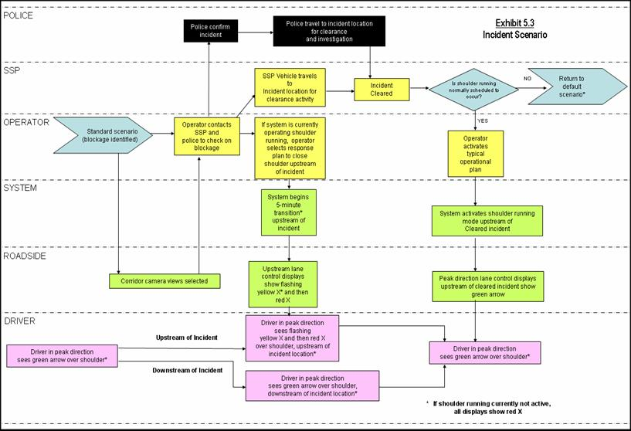
EXAMPLE #8 – OPERATIONAL SCENARIO

Section 8 – Next Steps
Section 8 – Next Steps identifies the next steps for the project following completion of the Concept of Operations. These steps should be consistent with the Systems Engineering Process and should be in compliance with FHWA Rule 940. Each step identifies ‘what’ needs to be done and by ‘whom’. These steps include:
- High-level and Detailed Requirements – In this step, stakeholder needs identified in the Concept of Operations are reviewed, analyzed, and transformed into verifiable requirements that define what the system will do but not how the system will do it. Working closely with stakeholders, the requirements are elicited, analyzed, validated, documented, and baselined.
- System Design – In this step, a system design is created based on the system requirements including a high-level design that defines the overall framework for the system. Subsystems of the system are identified and decomposed further into components. Requirements are allocated to the system components, and interfaces are specified in detail. Detailed specifications are created for the hardware and software components to be developed, and final product selections are made for off-the-shelf components.
- Software / Hardware Development Field Installation – In this step, hardware and software solutions are created for the components identified in the system design. Part of the solution may require custom hardware and/or software development, and part may be implemented with off-the-shelf items, modified as needed to meet the design specifications. The components are tested and delivered ready for integration and installation.
- Integration and Verification – In this step, the software and hardware components are individually verified and then integrated to produce higher-level assemblies or subsystems. These assemblies are also individually verified before being integrated with others to produce yet larger assemblies, until the complete system has been integrated and verified.
- System Validation – In this step, after the ITS system has passed system verification and is installed in the operational environment, the system owner/operator, whether the state DOT, a regional agency, or another entity, runs its own set of tests to make sure that the deployed system meets the original needs identified in the Concept of Operations.
- Operations & Maintenance – In this step, once the customer has accepted the ITS system, the system operates in its typical steady state. System maintenance is routinely performed and performance measures are monitored. As issues, suggested improvements, and technology upgrades are identified, they are documented, considered for addition to the system baseline, and incorporated as funds become available. An abbreviated version of the systems engineering process is used to evaluate and implement each change. This occurs for each change or upgrade until the ITS system reaches the end of its operational life.

DEVELOPING A CONCEPT OF OPERATIONS
Although there is no single recipe for developing a Concept of Operations, successful efforts will include a few key activities:

- Identify the stakeholders associated with the system/project – Systems engineering in general, and this effort in particular, require broad participation from the project's stakeholders. One of the first steps in developing a Concept of Operations is to make sure that all the stakeholders involved in or impacted by the project – owners, operators, maintainers, users, and so forth – are identified and involved. You can start with the stakeholder list from the regional ITS architecture and then expand it to identify the more specific organizations – divisions and departments – that should be involved.

- Define the core group responsible for creating the Concept of Operations – Although broad involvement is critical, you can't have 20 people on your writing team. Select a few individuals who are responsible for capturing and documenting the vision of the broader group. Depending on the size of the project and staff capabilities, this team might include a consultant or staff members with knowledge of the project and requisite writing and communications skills.

The best person to write the Concept of Operations may not be the foremost technical expert on the proposed system. A person skilled with organizing and facilitating stakeholder outreach, consensus building, and the ability to understand and clearly document the larger picture are key credentials for the Concept of Operations developer.

The stakeholders are the foremost experts on their needs and must be materially involved in the Concept of Operations development. The consultant can provide technical expertise on what should be in a Concept of Operations, facilitate the meetings and outreach activities, prepare the document, and coordinate the review, but the stakeholders' concept should be documented in the end. The stakeholders should consider the Concept of Operations their document, not the consultant's document.

- Define stakeholder needs – This is a key purpose of the Concept of Operations – to capture a clear definition of the stakeholders' needs and constraints that will support system requirements development in the next step. Interviews, workshops, and surveys are some of the techniques that are used to perform this activity. The Concept of Operations is a great tool for defining needs since it forces the stakeholders to think about the way the system will behave and how it will interact with users and other systems. The operational scenarios in the Concept of Operations are among the best tools for discovering needs. The list of needs that is generated should be prioritized by the stakeholders. Once they start to compare and rank the needs, they will discover that some of their "needs" are really "wants" or "nice-to-haves".

- Develop the initial Concept of Operations, review it with the broader group of stakeholders, and iterate – Incrementally create the Concept of Operations, review relevant portions with stakeholders, and adjust the concept as necessary to get buy-in. All stakeholders do not have to agree on every aspect of the project, but all must feel that they are achieving their major goals for the project.

Portions of the Concept of Operations can often be created from existing documents. For example, the regional ITS architecture identifies stakeholder roles and responsibilities that can be used. A feasibility study, project study report, or other preliminary study documentation may provide even more relevant information. A project application form used to support project fiscal programming will normally include goals, objectives, and other information that should be reflected in the Concept of Operations for continuity.

Operational scenarios are an excellent way to work with the stakeholders to define a Concept of Operations. Scenarios associated with a major incident, a work zone, or another project-specific situation provide a vivid context for a discussion of the system's operation. It is common practice to define several scenarios that cover normal system operation (the "sunny day" scenario) as well as various fault-and-failure scenarios.

- Create a System Validation Plan – A Validation Plan provides a guide for evaluating a deployed ITS system to determine if it has met its goals. The Validation plan should list criteria for judging whether or not the ITS system meets the user needs and objectives defined in the Concept of Operations. Typically, a Traceability Matrix is developed to map user needs to requirements. This helps ensure that the user needs are carried forward into design. An example of a Traceability Matrix is provided in the example below.

EXAMPLE #7 – TRACEABILITY MATRIX
(from VDOT NRO’s CCTV Master Concept of Operations)

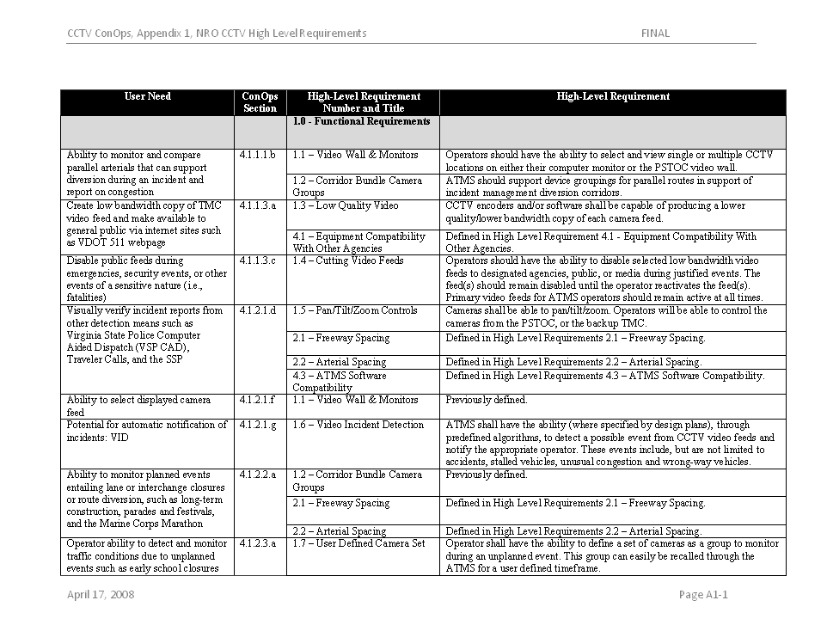

REFERENCES

- ANSI/AIAA, Guide for the Preparation of Operational Concept Documents, ANSI/AIAA G-043-1992.

- FHWA Rule 940/FTA Policy, http://www.ops.fhwa.dot.gov/its_arch_imp/policy.htm

- International Council on Systems Engineering (INCOSE), INCOSE Systems Engineering Handbook, http://www.incose.org

- TMC Pooled-Fund Study, Developing and Using a Concept of Operations in Transportation Management Systems, , http://tmcpfs.ops.fhwa.dot.gov/cfprojects/new_detail.cfm?id=38&new=0

- United Stated Department of Transportation (USDOT), Systems Engineering for Intelligent Transportation Systems, January 2007. http://ops.fhwa.dot.gov/int_its_deployment/sys_eng.htm

- United States Department of Transportation (USDOT), Regional ITS Architecture Use and Maintenance Workshop, Charlottesville, VA. April 2009.

- Virginia Department of Transportation (VDOT), Systems Engineering and Architecture Compliance (Rule 940) Checklist for Use in Northern Virginia, http://www.vdot-itsarch.com/Default.htm

APPENDIX – CONCEPT OF OPERATIONS TEMPLATE
<Insert Project Title> Concept of Operations

- SCOPE
  - Introduction, System Overview, and Purpose
  - Project Limits
  - System Vision, Goals, and Objectives
  - Role of the Concept of Operations in the Systems Engineering Process

- REFERENCED DOCUMENTS

- OPERATIONAL DESCRIPTION
  - Stakeholders Roles and Responsibilities
  - Locations of Existing ITS Infrastructure
  - Operational Procedures and Sequences of Events

- OPERATIONAL NEEDS
  - Operational Need Category 1
  - Operational Need Category 2
  - Operation Need Category X

- SYSTEM OVERVIEW
  - Description of the System(s)
- Proposed Content / Functionality
- Proposed Locations
- Software Implications
- Communication Requirements
  - Project Architecture
- Stakeholder / Element Descriptions
- Interconnect Diagram(s)
- Information Flow Diagram(s)

- OPERATIONAL AND SUPPORT ENVIRONMENT
  - Facilities
  - Equipment
  - Hardware
  - Software
  - Personnel
  - Changes to Operational Procedures

- OPERATIONAL SCENARIOS
  - Scenario #1
  - Scenario #2
  - Scenario X

- NEXT STEPS
  - High-level and Detailed Requirements
  - System Design
  - Software / Hardware Development & Field Installation
  - Integration and Verification
  - System Validation
  - Operations & Maintenance


Northern Region Operations

June 2009

