


CORE ITS INFRASTRUCTURE DEPLOYMENT
Route 28 from Route 7 to Fairfax / Prince William County Line

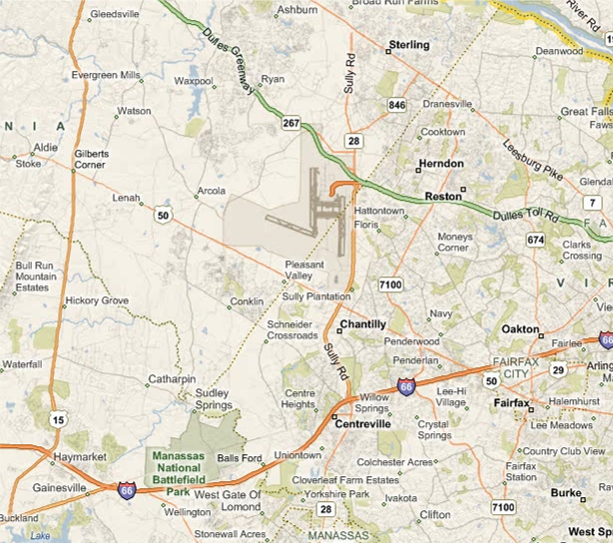
ITS COMPONENTS |  | COST ESTIMATE
- CCTV Cameras: 8  - Detectors: 12  - Other Devices: 0  (Please Specify) ______ | - Dynamic Message Signs: 3  - Telecom: 92,400 LF  - Software: No | Total: $ 7,526,750  Preliminary Engineering: $ 981,750  Construction: $ 6,545,000


CORE ITS INFRASTRUCTURE DEPLOYMENT
Route 28 from Route 7 to Fairfax / Prince William County Line
PROJECT OVERVIEW
DISTRICT: | NoVA | PROGRAM AREAS: | TBA
REGION: | Northern Region |  | TBA
JURISDICTION: | Loudoun, Fairfax, and Prince William Counties |  | TBA
PROJECT DESCRIPTION: | This project will deploy “core ITS infrastructure” on Route 28 in Loudoun and Fairfax Counties. Core ITS infrastructure includes closed circuit television (CCTV) cameras, detection, dynamic message signs (DMS), and communications.
ROAD SYSTEM: | PRIMARY | PRIMARY UPC: | N/A
ROUTE: | Route 28 | PE COST: | $ 981,750
FROM: | Route 7 | CN COST: | $ 6,545,000
TO: | Fairfax / PW County Line | TOTAL: | $ 7,526,750
ALLOCATIONS AND PROJECTED FUNDING
PROJECT PHASE |  | PREVIOUS ALLOCATION | FY 2011 | FY 2012 | FY 2013 | FY 2014 | FY 2015 | FY 2016
PE | Scoping/ConOps | $ - | $ - | $ - | $ - | $ - | $ - | $ -
PE | Pre. Field Review | $ - | $ - | $ - | $ - | $ - | $ - | $ -
PE | Utility Review | $ - | $ - | $ - | $ - | $ - | $ - | $ -
PE | Permits | $ - | $ - | $ - | $ - | $ - | $ - | $ -
PE | Soil Survey | $ - | $ - | $ - | $ - | $ - | $ - | $ -
PE | Design (PS&E) | $ - | $ - | $ - | $ - | $ - | $ - | $ -
CN | Procurement | $ - | $ - | $ - | $ - | $ - | $ - | $ -
CN | Installation | $ - | $ - | $ - | $ - | $ - | $ - | $ -
CN | CEI | $ - | $ - | $ - | $ - | $ - | $ - | $ -
CN | Integration | $ - | $ - | $ - | $ - | $ - | $ - | $ -
TOTAL |  | $ - | $ - | $ - | $ - | $ - | $ - | $ -
PRELIMINARY CN ESTIMATE
ITEM | DESCRIPTION | UNIT | QUANTITY | UNIT COST | TOTAL COST
1 | Dynamic Message Sign (DMS) | Each | 3 | $ 350,000 | $ 1,125,000
2 | Dynamic Message Sign (DMS) Upgrade | Each | 0 | $ 350,000 | $ -
3 | Closed Circuit Television (CCTV) Camera | Each | 8 | $ 55,000 | $ 440,000
4 | CCTV Upgrade with Existing Structure | Each | 0 | $ 20,000 | $ -
5 | Road Weather Information System (RWIS) | Each | 0 | $ 100,000 | $ -
6 | Detection | Each | 12 | $ 30,000 | $ 360,000
7 | Lane Control Signals (LCS) | Each | 0 | $ 35,000 | $ -
8 | Video Incident Detection (VID) | Each | 0 | $ 30,000 | $ -
9 | Communication (96 Strands) | LF | 92,400 | $ 50.00 | $ 4,620,000
TOTAL CONSTRUCTION ESTIMATE |  |  |  |  | $ 6,545,000

CORE ITS INFRASTRUCTURE DEPLOYMENT
Route 28 from Route 7 to Prince William/Fauquier County Line

PROJECT OVERVIEW
This Intelligent Transportation System (ITS) Plan for the Virginia Route 28 Corridor in Loudoun, Fairfax, and Prince William Counties recommends ITS improvements for the corridor that will promote traffic safety and mobility on this segment of Route 28. ITS refers to efforts to add information and communications technology to transport infrastructure and vehicles in an effort to manage factors that typically are at odds with each other, such as vehicles, loads, and routes to improve safety and reduce vehicle wear, transportation times, and fuel consumption.

ITS and operational recommendations identified in this report are consistent with the Virginia Department of Transportation’s (VDOT) Northern Region Operations (NRO) Strategic Plan, developed in November 2008. ITS device locations are consistent with Master Plans developed in 2008 by VDOT NRO for dynamic message signs (DMS), closed circuit television (CCTV) cameras, and vehicle detection.

Route 28 is a major artery through Northern Virginia that connects US Route 29 in Fauquier County to VA Route 7 in Loudoun County. It traverses Fauquier, Prince William, Fairfax, and Loudoun Counties and is a major access route to Washington Dulles International Airport (Dulles Airport). Because of its proximity to Dulles Airport, there are a relatively high number of drivers on Route 28 who have not frequently driven on this road. Additionally, Route 28 is a heavily used commuter route.

For the purposes of this Plan, the study limits were identified as the VA 28 interchange with Fairfax County / Prince William County Line on the south and the VA 28 interchange with VA 7 (Harry Byrd Highway) on the north.

GOALS AND OBJECTIVES
VDOT’s vision for the region and also for the Project Corridor is to:

Make Roadway Travel Safe, Efficient, and Reliable.

To meet this vision, VDOT NRO plans to:
- Serve the public by providing them with the information they need to make good travel decisions;
- Monitor real-time traffic conditions and the condition of its infrastructure;
- Proactively and rapidly identify problems, including traffic congestion, crashes, and other mobility and safety needs;
- Take rapid and effective action to address current and developing problems, appropriately applying a range of methods including physical improvements and advanced technologies;
- Share information, coordinate responses, and plan jointly with its partner agencies.

Goals and objectives met by this project include:

GOALS AND OBJECTIVES  [ Mark the goals and objectives that apply to this project with an “X” ] |  | EXPECTED BENEFITS
• | Goal #1: Reduce Congestion | - Reduction in travel times  - Reduction in delay (vehicle hours)  - Reduction in incident duration  - Improved travel time reliability
• | 1.1 Reduce travel times and delays for all modes along identified major corridors
• | 1.2 Improve travel time reliability on major corridors
• | 1.3 Actively manage travel demand on NRO facilities
• | 1.4 Reduce delays due to work zones and planned special events
• | 1.5 Reduce incident clearance times
• | Goal #2: Improve Safety | - Reduction in incidents
• | 2.1 Reduce vehicular crashes | - Reduction in incidents
 | 2.2 Reduce pedestrian and bicyclist crashes | - Reduction in incidents
• | Goal #3: Enhance Communications with Travelers | - Improved customer satisfaction
• | 3.1 Provide proactive, timely, and accurate information and responses to the traveling public | - Improved customer satisfaction
 | Goal #4: Promote Environmental Responsibility | - Reduction in fuel consumption
 | 4.1 Reduce energy consumption and environmental costs of transport operations | - Reduction in fuel consumption
• | Goal #5: Preserve and Manage an Integrated Traffic Management System | - Improved field infrastructure reliability  - Improved data availability to support operations and performance monitoring
• | 5.1 Maintain field infrastructure so that it operations reliably
 | 5.2 Improve information gathering on freeways and arterials
• | Goal #6: Improve Emergency Management | - Improved emergency management coordination  - Reduction in critical asset vulnerability
• | 6.1 Enhance coordination of regional emergency management
• | 6.2 Reduce NRO critical asset vulnerability
 | Goal #7: Improve the NRO Business Process | - Reduction in project delivery time  - Enhanced relationship between NRO investments and strategic goals and objectives  - Increased SWAM business utilization  - Improved percentage of projects completed on-time and within-budget
 | 7.1 Optimize operations planning, programming and project delivery time
 | 7.2 Make the rationale for all NRO investments clear and consistent
 | 7.3 Make performance-based decisions
 | 7.4 Utilize equal employment opportunity practices in hiring and
 | 7.5 Minimize project cost and schedule overruns
 | Goal #8: Improve Regional Operations Coordination and Efficiency | - Improved day-to-day regional operations coordination  - Increased application of operations solutions to regional transportation problems
 | 8.1 Encourage application of technology-based operations solutions in all relevant construction projects
 | 8.2 Improve operations planning with regional operations partners
 | 8.3 Improve day-to-day information exchange with regional operations partners
 | Goal #9: Enhance and Develop NRO Workforce Capabilities | - Improved NRO workforce knowledge-base  - Improved NRO workforce retention  - Reduction in workforce accidents
 | 9.1 Enhance Workforce needs planning to prepare for the future operations
 | 9.2 Support and sustain a learning environment for NRO staff
 | 9.3 Attract and retain a diverse talented workforce
 | 9.4 Reduce workplace accidents

EXISTING CONDITIONS
Although, Route 28 is one of the major north / south arterials west of the Capital Beltway that would obviously benefit from ITS instrumentation, there are no existing ITS devices within the study limits. This is typical of most arterials in Northern Region since VDOT’s ITS deployments have been primarily focused on interstates. To address this deficiency, VDOT NRO recently completed Master Plans to expand ITS device coverage onto major arterials and evacuation corridors. This includes the deployment of closed circuit television (CCTV) cameras, detection, and dynamic message signs (DMS) at strategic locations.

Since ITS devices have not been utilized in this corridor, it also lacks the concomitant communications infrastructure. Existing traffic signal controllers are connected by way of leased lines. VDOT’s 2006 “Strategic Go Forward Plan” recommended the installation of fiber optic communications along the corridor, from Route 234 to Route 7, to support future ITS devices. This installation would support a redundant fiber communications ring for VDOT.

While no ITS devices or communications infrastructure are currently located within the study limits, VDOT NRO recently deployed a new Advanced Traffic Management System (ATMS) in November 2008. The new ATMS has resulted in significant improvements to traffic operations, not only in Northern Virginia, but also statewide as it has facilitated regional collaborations with other transportation operation centers, agencies, and institutions throughout Virginia. The ATMS enables VDOT’s Northern Region Transportation Operations Center (TOC), the McConnell Public Safety and Transportation Operations Center (MPSTOC), to achieve the following objectives in a more efficient, accurate, and timely manner:
- Respond efficiently to incidents;
- Enhance the regional collaborations with other agencies;
- Improve transportation security (i.e., safe and efficient evacuations);
- Operate the transportation system effectively and efficiently;
- Maximize the effectiveness and efficiency of personnel, equipment and resources; and
- Enhance and simplify VDOT’s interactions with travelers.

The system is designed to allow operators to communicate and coordinate actions with a variety of field personnel, a variety of other systems (public safety systems, other freeway systems, transit systems, public information systems, media, etc.), and a variety of field devices (closed circuit television cameras, dynamic message signs, ramp meters, gates, highway advisory radio, etc.). It has more than enough capacity to operate any ITS equipment installed in Loudoun County’s Route 28 Corridor.

OPERATIONAL NEEDS
This section identifies specific needs for the corridor that should drive the requirements for future systems deployment. These needs have been identified through a series of ITS Master Planning efforts led by the VDOT NRO Planning & Programming Section. This Plan reflects input from planning, engineering, operations, maintenance, and research staff. Operational needs and concerns for the corridor are described below:
- Incident and Event Monitoring. Provide MPSTOC the ability to remotely detect and visually verify incidents that are reported by Safety Service Patrols, police, traveler calls, and other means. This includes observing and monitoring the status of the incident response at key “high accident” locations by first responders.
- Monitor Congestion Levels. Provide the ability to quickly identify anomalies in traffic patterns in order to: (1) detect and respond to incidents and (2) provide accurate and timely traveler information to the traveling public. This includes informing travelers of current traffic levels with particular attention to how they deviate from what is normal. This includes the collection of speed, volume, and occupancy information.
- Support Corridor Management. Monitor operations on Route 28 in concert with monitoring parallel freeways and arterials, compare relative levels of congestion, and support diversion to a lesser congested facility(s) during incidents and reports of congestion. This includes providing the ability to monitor mainline lanes, merge areas, diverge areas, and weave areas.
- Disseminate Real-time Information. Disseminate messages on dynamic message signs (DMS) in accordance with the following real-time applications:
  - Incidents;
  - Construction and maintenance activities;
  - Adverse weather, environmental, and roadway conditions;
  - Travel times;
  - Planned events;
  - Emergency messages;
  - Ozone alerts; and
  - Safety messages.
- Monitor Planned Events. Provide the ability to monitor planned events that would entail lane or interchange closures or route diversions, such as construction, parades, festivals, or other special events. Information collected will allow VDOT to use historical traffic data to set allowable hours for scheduled maintenance or construction. Additionally, VDOT will be able to evaluate the planned event’s impact on traffic.
- Share Video Images. Provide the ability to share real-time video images with first responders. This includes Virginia State Police, Loudoun or Fairfax County Police, and local fire and rescue agencies. Video images should also be shared with the media and general public.
- Collect and Provide Travel-Time Information. Provide the ability to show real-time travel times between certain points of interest on message boards, 511, and other dissemination tools in order to alert travelers of traffic delays.
- Measure Mainline and Ramp Volumes. Traffic Engineers need the ability to collect volume data on the mainline and ramps to perform traffic studies. This includes spot studies for safety and mobility, signal warrants, etc.
- Provide Data to the Private Sector. The private sector has a need for real-time, high quality traffic data to provide travel information to travelers. This includes companies that provide traffic information on websites and in-vehicle navigation systems. VDOT currently shares this traffic data with the private sector.

SYSTEM OVERVIEW
Based on the needs identified above, the following ITS Recommendations are made for Loudoun County’s Route 28 Corridor. These recommendations are focused on addressing traffic management, incident management, and traveler information.

Dynamic Message Signs

Three (3) dynamic message signs (DMS) are recommended for deployment within the study limits. These signs are proposed to be located on Route 28 at the following locations:
- Southbound DMS prior to Sterling Blvd
- Northbound DMS between Route 50 and the Dulles Toll Road
- Southbound DMS between the Dulles Toll Road and Route 50

Information disseminated will convey messages on incidents; construction and maintenance activities; adverse weather, environmental conditions; future travel times; planned events; emergency messages; ozone alerts; and safety messages.

The proposed DMS’s will post messages pertaining to mainline Route 28, as well as the Dulles Toll Road and I-66. By providing motorists with information prior to decision points, it will allow motorists to make informed en-route decisions about their trip. For example, a motorist traveling SB on Route 28 has several options for getting to Tysons Corner; they could take the Dulles Toll Road (DTR) or I-66 eastbound (EB). Generally, the motorist takes the DTR because they believe the commute is shorter. However, should a major incident occur on the EB DTR while they are SB on Route 28 during their commute, the DMS would convey this information to the motorist, who could then decide whether to travel on EB DTR or to continue SB Route 28 to I-66 and use EB I-66 to access Tysons.

The proposed DMS’s will be integrated into VDOT’s OpenTMS software at MPSTOC where it will be controlled by VDOT’s TOC Operators. Figure 1 depicts the location of the proposed DMS. Additionally, it identifies proposed locations for DMS on Route 28 in Fairfax County, as a reference for future planning.

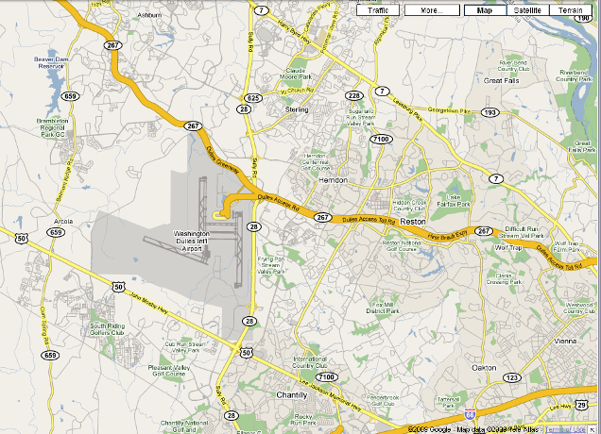
Proposed Dynamic Message Signs (DMS)

- Southbound DMS prior to Sterling Blvd

- (Fairfax County) NB DMS between Route 50 and the Dulles Toll Road. *

- (Fairfax County) Southbound DMS between the Dulles Toll Road and Route 50. *

* NOTE: Consider dual gantry for installation of DMS, if possible.

Figure 1. Proposed DMS Locations.

Closed Circuit Television Cameras

Eight (8) closed circuit television (CCTV) cameras are proposed within the study limits. These proposed locations include:
- The Route 28 and VA-7 Interchange.
- The Route 28 and Nokes Boulevard Interchange.
- The Route 625 Interchange
- The Route 28 and Sterling Boulevard Interchange.
- The Route 28 and VA 267 Interchange.
- The Route 28 and Frying Pan Road Interchange.
- The Route 28 and the Air and Space Museum Parkway Interchange.
- The Route 28 and Westfields Boulevard Interchange.

These Proposed locations are depicted in Figure 2.

Proposed Closed Circuit Television (CCTV) Cameras

- CCTV Camera at the Route 28 and VA-7 Interchange.
- CCTV Camera at the Route 28 and Nokes Boulevard Interchange.
- CCTV Camera at the Route 625 Interchange
- CCTV Camera at the Route 28 and Sterling Boulevard Interchange.
- CCTV Camera at the Route 28 and VA 267 Interchange.
- (Fairfax County) CCTV Camera at the Route 28 and Frying Pan Road Interchange.
- (Fairfax County) CCTV Camera at the Route 28 and the Air and Space Museum Parkway Interchange.
- (Fairfax County) CCTV Camera at the Route 28 and Westfields Boulevard Interchange.

Figure 2. Proposed CCTV Camera Locations.

The proposed CCTV cameras will be deployed to allow VDOT’s Transportation Operations Center (TOC) to detect, verify, and monitor incidents and construction activities. All cameras will be integrated into OpenTMS. By remotely viewing on the ground conditions, operators can quickly and effectively assess what kind of actions and resources need to be implemented to send to an incident site. Additionally, VDOT will share these video images with the first responder community and the general public using its statewide video sharing clearinghouse, currently TrafficLand. CCTV images will be available on VDOT’s 511 website (www.511virginia.org) and its Statewide Video-sharing Clearinghouse, currently TrafficLand (www.trafficland.com).

Detection

Non-intrusive detection is proposed along Route 28 to collect speed, volume, and occupancy information. Detectors are proposed between interchanges on Route 28. Data from the detection devices will bee aggregated and evaluated at central control locations to identify current travel speeds and volumes. This information will feed OpenTMS and may be used for public web sites. Volume data will be archived to track trends in traffic volumes in time and space. In the past, sharp changes in volume, occupancy and speed have been used to trigger alarms of potential incident occurrence with mixed success due to the complexity of identifying incidents separately from congestion breakdowns.

VDOT also shares detector data with private agencies who in turn use the information to display travel times on congestion information on private websites (i.e., Google and Mapquest) or incorporate the traffic information in in-vehicle navigation systems.

Proposed Detection

- Between VA-7 and Nokes Blvd.
- Between Nokes Blvd. and Route 625
- Between Route 625 and Sterling Blvd.
- Between Sterling Blvd. and Route 606
- Between Route 606 and the Dulles Toll Road
- (Fairfax County) Between Dulles Toll Road and Frying Pan Road
- (Fairfax County) Between Frying Pan Road and McLearen Road
- (Fairfax County) Between McLearen Road and Barnsfield Road
- (Fairfax County) Between Barnsfield Road and Route 50
- (Fairfax County) Between Route 50 and Willard Road
- (Fairfax County) Between Willard Road and Westfields Blvd.
- (Fairfax County) Between Westfield Blvd. and I-66

Figure 3. Proposed Detector Locations.

Communications

In order for the proposed ITS devices to communicate with OpenTMS at MPSTOC, it will require communications infrastructure tying back into existing VDOT fiber. VDOT currently has fiber running along the Dulles Toll Road. It is proposed as part of this project to include a fiber connection along Route 28. Per VDOT’s 2006 “Strategic Go Forward Plan”, this fiber was recommended to support future ITS device expansion as well as installing a redundant fiber communications ring for VDOT.

PROJECT ARCHITECTURE
The Project Architecture provides a framework that identifies the institutional agreement and technical integration necessary to interface the ITS project with other ITS projects and systems. It addresses the application of the proposed system with a focus on integration and operation of the system(s). The sections below summarize key stakeholders, elements, and ITS Market Packages impacted by the proposed project.

“Key” Regional Stakeholders Impacted

The following stakeholders will be directly impacted and/or benefit from this project:
- VDOT NRO – The VDOT NRO operates and manages the VDOT roadways and facilities in the Northern Regional Operations area defined by the VDOT NOVA District and a part of the VDOT Fredericksburg District. The VDOT NRO operates the Traffic Operations Center and the Traffic Signal System, operates snow plows and the safety service patrol.
- Private Sector ISPs – Information Service Providers (ISP) who provide value added transportation information to the public in the NRO region.
- Video Clearinghouses – This stakeholder represents entities acting as an agent for VDOT for video distribution. VDOT policy allows up to three private contractors to serve as video clearinghouses.

“Key” Elements Impacted

The following elements will be directly impacted and/or benefit from this project:
- VDOT NRO MPSTOC – TOC CCTV Cameras – This element represents the CCTV cameras that are installed along the roadside which aid the operators in TOC in managing and monitoring traffic conditions on freeway. The operators in TOC can control the cameras and get the images of roadway from the cameras.
- VDOT NRO MPSTOC – TOC Detection – This element represents the detection elements that are located along the roadside and are controlled by operators in the TOC which aids them in monitoring and managing traffic conditions. An example is a vehicle detector on roadway.
- VDOT NRO MPSTOC – TOC DMS – This element represents the variable message signs installed along the roadside which aids the operators in TOC in managing traffic conditions on freeway.
- VDOT NRO MPSTOC – TOC – The McConnell Public Safety and Transportation Operations Center (MPSTOC) is on West Ox Road at the Fairfax County Parkway, housing the Fairfax County Department of Public Safety Communications (9-1-1 Communication Center), the Office of Emergency Management and the county's Emergency Operations Center, along with the Virginia State Police Division 7 dispatchers and call-takers. MPSTOC is a nerve center of an integrated system of advanced technologies including computer software, traffic cameras, lane control strategies, ramp meters, reversible control gates, and HOV lane restrictions. From the MPSTOC, VDOT monitors and manages traffic, recognizes and responds to incidents, and instantly delivers information to motorists. VDOT MPSTOC is responsible for monitoring and managing traffic conditions on I-495, I-95/395, and I-66. It includes OpenTMS Software, the ASSIST Program, LCMS (Lane Closure Management System) and HAR.
- VDOT Video Clearinghouses – Statewide video clearinghouse for dissemination of VDOT and other agency video images in the region. This element also represents a desire to include DC and MD video into the video clearinghouse.

“Key” ITS Market Packages

The project impacts the following ITS Market Packages:

- ATMS01 – Network Surveillance – VDOT NRO MPSTOC: This market package includes traffic detectors and other CCTV equipment that are deployed in the NRO area to allow the VDOT NRO MPSTOC - TOC to monitor traffic and road conditions, identify and verify incidents, detect faults in indicator operations, and collect census data for traffic strategy development and long range planning. The collected detector and CCTV data is being sent to Private Sector ISP Centers and VDOT Video Clearinghouse to be analyzed and made available to the public.
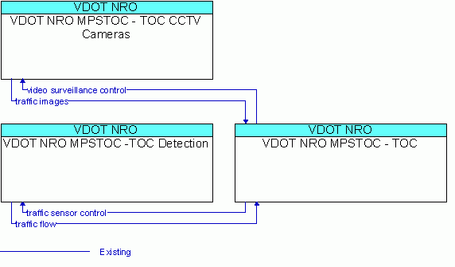
- ATMS04 – Freeway Control – VDOT NRO MPSTOC: This market package includes traffic detectors and other CCTV equipment that are deployed in the NRO area to allow the VDOT NRO MPSTOC - TOC to monitor traffic and road conditions, identify and verify incidents, detect faults in indicator operations, and collect census data for traffic strategy development and long range planning. The collected detector and CCTV data is being sent to Private Sector ISP Centers and VDOT Video Clearinghouse to be analyzed and made available to the public.

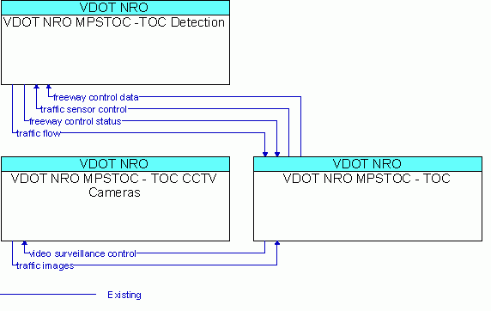

- ATMS06 - Traffic Information Dissemination: This market package reflects the VDOT NRO MPSTOC-TOC's ability to provide traffic information to drivers using roadway equipment such as dynamic message signs or highway advisory radio. The VDOT NRO MPSTOC -TOC disseminates a wide range of information including traffic and road conditions, road closure and detour information, incident information, and emergency alerts and driver advisories. Incident information detected by the NRO Local Public Safety Centers and Virgina State Police are also provided to the VDOT NRO MPSTOC -TOC for proper message postings. The VDOT NRO MPSTOC - TOC provides maintenance and construction activity to drivers based on information it receives from the VDOT NOVA District Maintenance and VDOT NRO Operations Maintenance. The market package also represents the VDOT NRO MPSTOC -TOC's plans to share incident information with the Virginia Statewide Information Clearinghouse and Private Sector ISP Centers for pre-trip or en-route dissemination to the public.

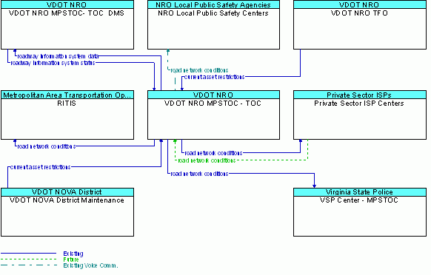

- ATMS07 - Regional Traffic Management: This market package provides for the planned sharing of traffic information among the VDOT NRO MPSTOC-TOC, VDOT NRO MPSTOC- Signal Center and NRO Local TOC's to support a regional control strategy. This market package advances the Surface Street Control and Freeway Control Market Packages by adding the communications links and integrated control strategies that enable integrated interjurisdictional traffic information sharing. If at some point in the future there is a desire to share control, then the nature of optimization and extent of information and potential control sharing will be determined through working arrangements between VDOT and the other jurisdictions.

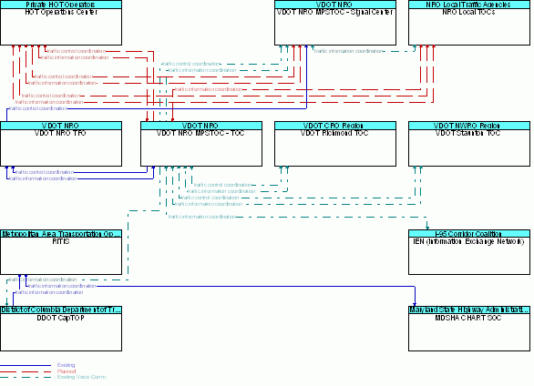

ITS STANDARDS
Table 1 provides a preliminary list of standards for consideration on this project. These standards were extracted from the Northern Virginia ITS Architecture associated with the architecture elements identified in Section 6 above. This list will need to be refined with more analysis.

IMPLEMENTATION RECOMMENDATION

TBA

